 | 7.2.1 Editors - 3D Viewport - Tool Shelf - Object Mode
Table of content
Detailed table of content 1
Tool Shelf - Object Mode 7
Select Tools Group 7
Cursor 8
Move Rotate Scale Transform 9
Move 9
Rotate 11
Scale Tools Group 13
Transform 18
Annotate Tools group 18
Annotate tool 19
Annotate Line 20
Annotate Polygon 21
Annotate Eraser 23
Measure 23
Primitives Add tools group 24

Detailed table of content
Detailed table of content
Detailed table of content 1
Tool Shelf - Object Mode 7
Select Tools Group 7
Tweak 7
Select Box 7
Tool Settings 7
Mode 7
Set a new selection 7
Extend existing selection 7
Subtract existing selection 7
Inverts existing selection 7
Intersect existing selection 7
Select Circle 8
Tool Settings 8
Mode 8
Set a new selection 8
Extend existing selection 8
Subtract existing selection 8
Radius 8
Select Lasso 8
Tool Settings 8
Mode 8
Set a new selection 8
Extend existing selection 8
Subtract existing selection 8
Inverts existing selection 8
Intersect existing selection 8
Cursor 8
Tool Settings 9
Surface Project 9
Orientation 9
Move Rotate Scale Transform 9
Move 9
Snapping 9
Precision movement 9
Header Values 9
Numerical Input 10
Move without widget 10
Limit Axis 10
Tool Settings 10
Orientation 10
Last Operator Move 10
Move X, Y Z 10
Orientation 11
Proportional editing 11
Proportional Falloff 11
Proportional Size 11
Connected 11
Projected(2D) 11
Rotate 11
Snapping 11
Precision rotation 12
Header Values 12
Numerical Input 12
Rotate without widget 12
Limit Axis 12
Tool Settings 12
Orientation 12
Last Operator Rotate 13
Angle 13
Axis 13
Orientation 13
Proportional editing 13
Proportional Falloff 13
Proportional Size 13
Connected 13
Projected(2D) 13
Scale Tools Group 13
Scale 14
Snapping 14
Precision Scale 14
Header Values 14
Numerical Input 14
Scale without widget 14
Limit Axis 14
Tool Settings 15
Orientation 15
Last Operator Resize 15
Angle 15
Axis 15
Orientation 15
Proportional editing 15
Proportional Falloff 15
Proportional Size 15
Connected 16
Projected(2D) 16
Scale Cage 16
Snapping 16
Header Values 16
Scale without widget 16
Limit Axis 16
Tool Settings 17
Orientation 17
Last Operator Resize 17
Angle 17
Axis 17
Orientation 17
Proportional editing 17
Proportional Falloff 17
Proportional Size 17
Connected 17
Projected(2D) 17
Transform 18
Tool Settings 18
Drag Action 18
Orientation 18
Annotate Tools group 18
Annotate tool 19
Tool Settings 19
Color 19
Note 19
Annotations list 19
Edit Box 19
Fake User 19
Add Annotation 19
Remove Annotation 19
Active Layer Index 20
Add Annotation Layer 20
Remove Annotation Layer 20
Opacity 20
Thickness 20
Frame Locked/Unlocked 20
Delete Active Frame 20
Placement 20
Stabilize Stroke 20
Radius 20
Factor 20
Annotate Line 20
Tool Settings 20
Placement 21
Style Start 21
End 21
Annotate Polygon 21
Tool Settings 21
Color 21
Note 21
Annotations list 22
Edit Box 22
Fake User 22
Add Annotation 22
Remove Annotation 22
Active Layer Index 22
Add Annotation Layer 22
Remove Annotation Layer 22
Opacity 22
Thickness 22
Frame Locked/Unlocked 22
Delete Active Frame 22
Placement 22
Annotate Eraser 23
Tool Settings 23
Radius 23
Measure 23
Restrict to global axis 23
Measuring angles 23
Snapping 24
Delete measure lines 24
Primitives Add tools group 24
Add Cube 25
Tool Settings 25
Depth 25
Position 25
Surface 25
3D Cursor Plane 25
3D Cursor View 25
Orientation 25
Snap To 25
Plane Axis 25
Auto Axis 25
Base 25
Origin 25
Aspect 25
Height 26
Origin 26
Aspect 26
Last Operator Add Cube Panel 26
Add Cone 26
Tool Settings 26
Depth 26
Position 26
Surface 26
3D Cursor Plane 26
3D Cursor View 26
Orientation 26
Snap To 27
Plane Axis 27
Auto Axis 27
Base 27
Origin 27
Aspect 27
Height 27
Origin 27
Aspect 27
Vertices 27
Base Fill Type 27
Last Operator Add Cone Panel 27
Add Cylinder 28
Tool Settings 28
Depth 28
Position 28
Surface 28
3D Cursor Plane 28
3D Cursor View 28
Orientation 28
Snap To 28
Plane Axis 28
Auto Axis 28
Base 29
Origin 29
Aspect 29
Height 29
Origin 29
Aspect 29
Vertices 29
Last Operator Add Circle Panel 29
Add UV Sphere 29
Tool Settings 30
Depth 30
Position 30
Surface 30
3D Cursor Plane 30
3D Cursor View 30
Orientation 30
Snap To 30
Plane Axis 30
Auto Axis 30
Base 30
Origin 30
Aspect 30
Height 31
Origin 31
Aspect 31
Segments 31
Rings 31
Last Operator Add UV Sphere Panel 31
Add Icosphere 31
Tool Settings 31
Depth 31
Position 31
Surface 31
3D Cursor Plane 32
3D Cursor View 32
Orientation 32
Snap To 32
Plane Axis 32
Auto Axis 32
Base 32
Origin 32
Aspect 32
Height 32
Origin 32
Aspect 32
Subdivisions 32
Last Operator Add Ico Sphere Panel 32

Tool Shelf - Object Mode

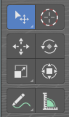
In Object mode you will see mainly the general select and transform tools.

Those tools will also appear in other modes like Edit mode. We will not cover it again there.

Select Tools Group

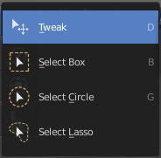
Tools with a triangle down right are a group of tools. Click and hold to reveal the content. Then choose the tool that you need.

Tweak
Allows you to select or tweak single elements by clicking at it.

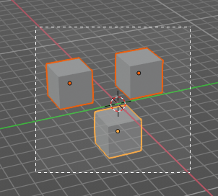
Select Box
Draws a box to select several elements at once. Click at the start point, then drag.

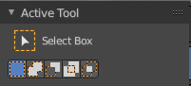
Tool Settings

Mode
The available selection modes. The mode titles are pretty self explaining. So i won't go into detail here.

Set a new selection

Extend existing selection

Subtract existing selection

Inverts existing selection

Intersect existing selection

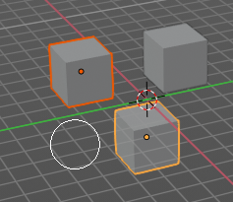
Select Circle
Draws a box to select several elements at once. Click at the start point, then drag.

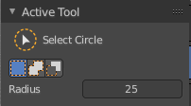
Tool Settings

Mode
The available selection modes. The mode titles are pretty self explaining. So i won't go into detail here.

Set a new selection

Extend existing selection

Subtract existing selection

Radius
The brush radius.

Select Lasso
Draws a box to select several elements at once. Click at the start point, then drag.

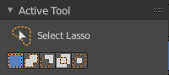
Tool Settings

Mode
The available selection modes. The mode titles are pretty self explaining. So i won't go into detail here.

Set a new selection

Extend existing selection

Subtract existing selection

Inverts existing selection

Intersect existing selection

Cursor
The cursor tool allows you to move the 3d cursor around.

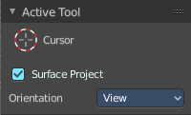
Tool Settings

Surface Project
Project the 3D cursor onto the surface.

Orientation
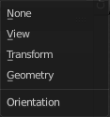
The 3d cursor can have different orientations. The menu items should be self explaining.

Move Rotate Scale Transform

The transformation tools.

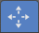
Move
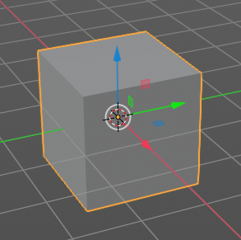
Activates the move tool. Activating the move tool also reveals a move widget at the object. This widget allows you to move the object around, by using the corresponding axis.
When you click at one of the square buttons at the icon, then you can move the object along the plane of the two adjacent axis. The rectangle buttons between the arrows allows you to move in direction of the blue and green arrows. This can also be done by clicking at the tip of the arrow and holding down shift. Then you can move the cube along the two other axis.

Snapping
Holding down Ctrl activates temporary global snapping.

Precision movement
When you hold down shift, then you will have a much slower but also much preciser movement.

Header Values
When you move your object then you will see some values in the header, which defines the current position of the object.
The value m stands for the default metric system. Meters. You can change the units in the Properties editor in the Scene properties in the Units panel. When you choose kilometers here then you will see a km instead m.
The value D stands for the distance of the current selected axis. This can also be two axis. Then you have two d values. The value in the brackets is then the direct distance to the starting point.
These values are always relative to the starting point. You always start with zero, regardless of the real world position.

Numerical Input
When you move the object, and hold down the mouse and type in a value, like 20, then the movement will be performed by the value that you have typed in. In this case by 20 units in direction of the selected axis.

Move without widget
You don't have to use the widget to move the object. You can also click aside of it, and drag the object around. The mouse turns into a move cursor. The standard behavior then is to move in screen space. When you want to move into a specific axis, then press X or Y or Z to limit the movement to this axis.

Limit Axis
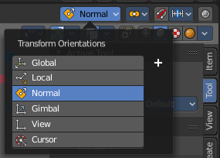
When you want to rotate a specific axis, then press X or Y or Z to limit the rotation to this axis. You usually start in global orientation. But you can change this in the Orientation settings.
By holding down the mouse button and pressing the X, Y or Z key twice you can toggle this to local. But also to other orientations. This depends in what orientation you start. With normal you can toggle that way between Normal and global.
This can be combined with the numerical input. Type in X, type in X again to use the local space, type in 20 to move by 20 units in local orientation. Release the mouse to confirm.

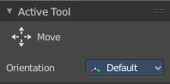
Tool Settings


Orientation
The widget can have different orientations. The menu items should be self explaining.

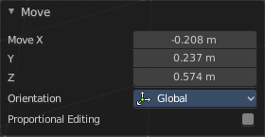
Last Operator Move

Move X, Y Z
The position. Attention, the actual world orientation and rotation does not matter here. It always starts with a value of zero, and moves relative to this zero then. For the actual location values have a look in the sidebar in the transform panel.

Orientation
The widget can have different orientations. The menu items should be self explaining.

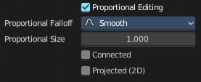
Proportional editing
Enables proportional editing. Activating proportional editing reveals further settings.

Proportional Falloff
Adjust the falloff methods.

Proportional Size
See and adjust the falloff radius.

Connected
The proportional falloff gets calculated for connected parts only.

Projected(2D)
The proportional falloff gets calculated in the screen space. Depth doesn't play a role. When it's in the radius, then it gets calculated.


Rotate
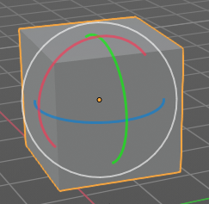
Activates the Rotate tool. Activating the move tool also reveals a rotate widget at the object. This widget allows you to rotate the object, by using the corresponding axis.

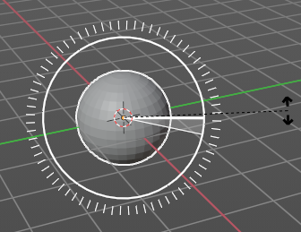
Snapping
Holding down Ctrl activates temporary global snapping. It snaps then by 5 degrees steps.
When you use the white circle to rotate, then the widget also shows a division circle around the widget. This divisions shows even finer when you do precision rotation.

Precision rotation
When you hold down shift, then you will have a much slower but also much preciser rotation.

Header Values
When you rotate your object then you will see some values in the header, which defines the current rotation of the object. The rotation is shown in degrees.

Numerical Input
When you rotate the object, and hold down the mouse and type in a value, like 20, then the rotation will be performed by the value that you have typed in. In this case by 20 degree around the selected axis.

Rotate without widget
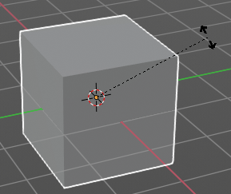
You don't have to use the widget to rotate the object. You can also click asides and drag the object around. A black arrow will appear. The standard behavior then is to rotate in viewport orientation.

Limit Axis
When you want to rotate a specific axis, then press X or Y or Z to limit the rotation to this axis. You usually start in global orientation. But you can change this in the Orientation settings.
By holding down the mouse button and pressing the X, Y or Z key twice you can toggle this to local. But also to other orientations. This depends in what orientation you start. With normal you can toggle that way between Normal and Global.
This can be combined with the numerical input. Type in X, type in X again to use the local space, type in 20 to rotate by 20 degree. Release the mouse to confirm.

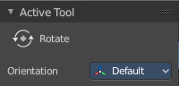
Tool Settings

Orientation
The 3d cursor can have different orientations. The menu items should be self explaining.

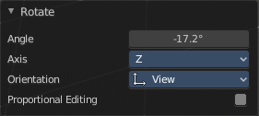
Last Operator Rotate

Angle
The rotation. Attention, the actual world orientation and rotation does not matter here. It always starts with a value of zero, and rotates relative to this zero then. For the actual rotation values have a look in the sidebar in the transform panel.

Axis
Which axis to rotate.

Orientation
The widget can have different orientations. The menu items should be self explaining.

Proportional editing
Enables proportional editing. Activating proportional editing reveals further settings.

Proportional Falloff
Adjust the falloff methods.

Proportional Size
See and adjust the falloff radius.

Connected
The proportional falloff gets calculated for connected parts only.

Projected(2D)
The proportional falloff gets calculated in the screen space. Depth doesn't play a role. When it's in the radius, then it gets calculated.

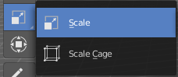
Scale Tools Group
You can use two scale tools with different widget styles.

Scale
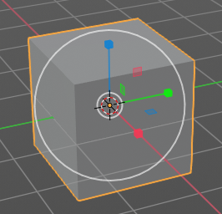
Activates the Scale tool. Activating the scale tool also reveals a traditional scale widget at the object. This widget allows you to scale the object, by using the corresponding axis. When you click at the outer white circle and drag, then you can scale the object uniformly.
The rectangle buttons between the arrows allows you to scale in direction of the adjacent arrows. This can also be done by clicking at the tip of the arrow and holding down shift. Then you can scale the cube along the two other axis.

Snapping
Holding down Ctrl activates temporary global snapping.

Precision Scale
When you hold down shift, then you will have a much slower but also much preciser scale.

Header Values
When you scale your object then you will see some values in the header, which defines the current scale of the object.
These values are always relative to the starting point. You always start with 1, regardless of the real world scale.

Numerical Input
When you scale the object, and hold down the mouse and type in a value, like 20, then the scale will be performed by the value that you have typed in. In this case by factor 20 along the selected axis.

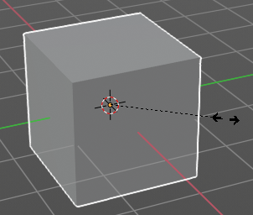
Scale without widget
You don't have to use the widget to scale the object. You can also click asides and drag the object around. A black arrow will appear. The standard behavior then is to scale uniformly. When you want to scale into a specific axis, then press X or Y or Z to limit the scale to this axis.

Limit Axis
When you want to rotate a specific axis, then press X or Y or Z to limit the scale to this axis. You usually start in global orientation. But you can change this in the Orientation settings.
By holding down the mouse button and pressing the X, Y or Z key twice you can toggle this to local. But also to other orientations. This depends in what orientation you start. With normal you can toggle that way between Normal and Global.
This can be combined with the numerical input. Hold down mouse, type in X, type in X again to use the local space, type in 20 to scale by 20 units. Release the mouse to confirm.

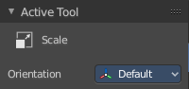
Tool Settings

Orientation
The 3d cursor can have different orientations. The menu items should be self explaining.

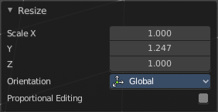
Last Operator Resize

Angle
The rotation. Attention, the actual world orientation and rotation does not matter here. It always starts with a value of zero, and rotates relative to this zero then. For the actual rotation values have a look in the sidebar in the transform panel.

Axis
Which axis to rotate.

Orientation
The widget can have different orientations. The menu items should be self explaining.

Proportional editing
Enables proportional editing. Activating proportional editing reveals further settings.

Proportional Falloff
Adjust the falloff methods.

Proportional Size
See and adjust the falloff radius.

Connected
The proportional falloff gets calculated for connected parts only.

Projected(2D)
The proportional falloff gets calculated in the screen space. Depth doesn't play a role. When it's in the radius, then it gets calculated.

Scale Cage
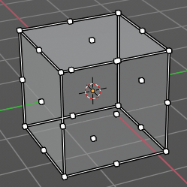
Activates the Scale tool. Activating the scale tool also reveals a scale widget in cage style at the object. This widget allows you to scale the object by clicking at the white handler points and drag them in the desired direction.

Snapping
Holding down Ctrl activates temporary global snapping.

Header Values
When you scale your object then you will see some values in the header, which defines the current scale of the object.
These values are always relative to the starting point. You always start with 1, regardless of the real world scale.

Scale without widget
You don't have to use the widget to scale the object. You can also click asides and drag the object around. A black arrow will appear. The standard behavior then is to scale uniformly. When you want to scale into a specific axis, then press X or Y or Z to limit the scale to this axis.

Limit Axis
When you want to rotate a specific axis, then press X or Y or Z to limit the rotation to this axis. You usually start in global orientation. But you can change this in the Orientation settings.
By holding down the mouse button and pressing the X, Y or Z key twice you can toggle this to local. But also to other orientations. This depends in what orientation you start. With normal you can toggle that way between Normal and Global.

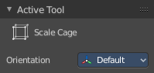
Tool Settings

Orientation
The 3d cursor can have different orientations. The menu items should be self explaining.

Last Operator Resize

Angle
The rotation. Attention, the actual world orientation and rotation does not matter here. It always starts with a value of zero, and rotates relative to this zero then. For the actual rotation values have a look in the sidebar in the transform panel.

Axis
Which axis to rotate.

Orientation
The widget can have different orientations. The menu items should be self explaining.

Proportional editing
Enables proportional editing. Activating proportional editing reveals further settings.

Proportional Falloff
Adjust the falloff methods.

Proportional Size
See and adjust the falloff radius.

Connected
The proportional falloff gets calculated for connected parts only.

Projected(2D)
The proportional falloff gets calculated in the screen space. Depth doesn't play a role. When it's in the radius, then it gets calculated.

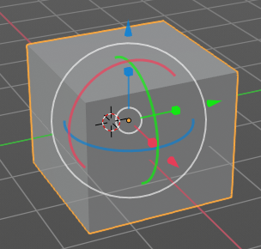
Transform
Transform reveals a multi transform widget with all three transform methods available at once. Move, Rotate and Scale.
The rules are the same than for the single tools, and also the last operators. Dependent of which widget part you pull here. So i won't go into detail again here.

Tool Settings

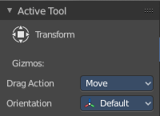
Drag Action
Define what kind of transform should happen when you click not at the widget but besides, and drag the mouse.

Orientation
The 3d cursor can have different orientations. The menu items should be self explaining.

Annotate Tools group
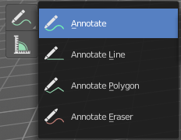
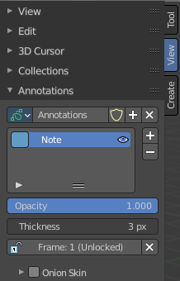
The annotation tool is available in multiple editors. With this tool you can write notes at the screen. The annotate tools is the little brother of the grease pencil objects.
Further settings for annotate can be found in the sidebar. Here you can also remove an annotation when you don't longer need it. And here you can also adjust the size of the stroke.
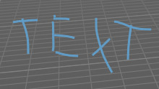

Annotate tool
Draw free-hand strokes in the main window.

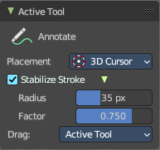
Tool Settings
The tool settings for the Annotate tool.

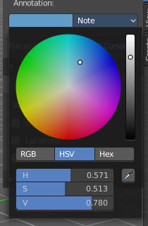
Color
Clicking at the left color field reveals a color picker. Define the color for the annotation stroke.

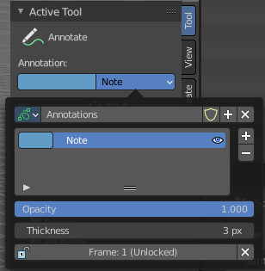
Note
Clicking at the Note drop down box reveals a panel with further settings. It's the same content than in the annotations in the View tab.

Annotations list

Add, remove and rename new annotations.

Edit Box
The name of the current annotation. You can rename the annotation to your needs here.

Fake User
Assign a fake user to this annotation. Fake users is an odd concept to keep data in the scene even if it has no user somewhere. The fake user is then a dummy user so that the object is not deleted when saving the scene.

Add Annotation
Add a new annotation.

Remove Annotation
Delete the annotation.

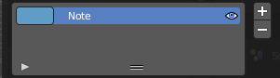
Active Layer Index
The list of annotation layers.

Add Annotation Layer
Add a new annotation layer.

Remove Annotation Layer
Remove the selected annotation layer.

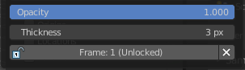
Opacity
The opacity of the stroke.

Thickness
The thickness of the annotation stroke.

Frame Locked/Unlocked
Lock frame displayed by current layer. This toggles whether the active layer is the only one that can be edited.

Delete Active Frame
Deletes the active frame from the active grease pencil layer.

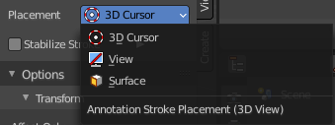
Placement
Define how annotation strokes are aligned in the 3d space.

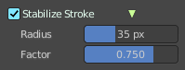
Stabilize Stroke
Helper to draw smooth and clean lines. Pressing shift inverts the effect.

Radius
The radius for the stroke stabilization.

Factor
Stabilizer stroke factor. Higher values gives a smoother stroke.

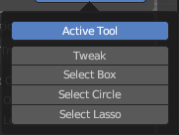
Drag
Define what kind of transform should happen when you click not at the widget but besides, and drag the mouse.

Annotate Line
Click and drag to create a line.

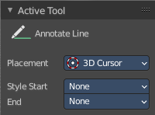
Tool Settings
The tool settings for the Annotate tool.

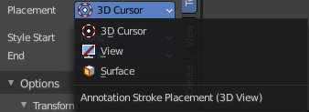
Placement
Define how annotation strokes are aligned in the 3d space.

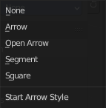
Style Start
The stroke start style. With an arrow for example you place an arrow at the start of the stroke.

End
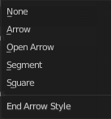
The stroke end style. With an arrow for example you place an arrow at the end of the stroke.

Annotate Polygon
Click multiple times to create multiple connected lines. The current polygon is finished when Esc or RMB is pressed.

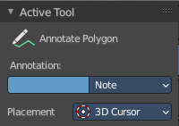
Tool Settings
The tool settings for AnnotatePolygon.

Color
Clicking at the left color field reveals a color picker. Define the color for the annotation stroke.

Note
Clicking at the Note drop down box reveals a panel with further settings. It's the same content than in the annotations in the View tab.

Annotations list
Add, remove and rename new annotations.

Edit Box
The name of the current annotation. You can rename the annotation to your needs here.

Fake User
Assign a fake user to this annotation. Fake users is an odd concept to keep data in the scene even if it has no user somewhere. The fake user is then a dummy user so that the object is not deleted when saving the scene.

Add Annotation
Add a new annotation.

Remove Annotation
Delete the annotation.

Active Layer Index
The list of annotation layers.

Add Annotation Layer
Add a new annotation layer.

Remove Annotation Layer
Remove the selected annotation layer.

Opacity
The opacity of the stroke.

Thickness
The thickness of the annotation stroke.

Frame Locked/Unlocked
Lock frame displayed by current layer. This toggles whether the active layer is the only one that can be edited.

Delete Active Frame
Deletes the active frame from the active grease pencil layer.

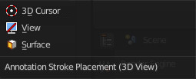
Placement
Define how annotation strokes are aligned in the 3d space.

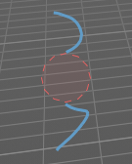
Annotate Eraser
Click and drag to remove annotate lines.

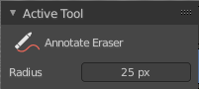
Tool Settings

Radius
The radius of the eraser pencil.

Measure
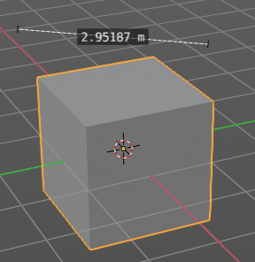
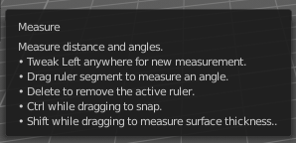
Measure allows you to draw measure lines into the view.
The measure tool has a few options, which are described in the tool tip.
New measure lines gets created by left clicking and dragging.
When you change the tool then the measure lines becomes visible. But they are not removed. When you activate the measure tool then they reappear.

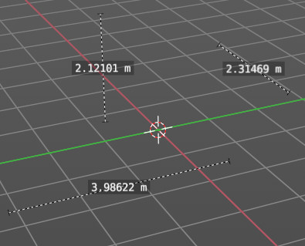
Restrict to global axis
You can constraint the measure tool to a single global axis by pressing the corresponding X Y or Z key once while holding down the mouse.
To escape this constraint, press the axis key twice again.

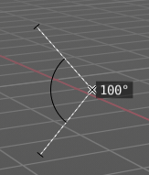
Measuring angles
When you want to measure an angle, first create a straight measure line. Then grab it in the middle to drag out a new point at the line. Then align everything proper.

Snapping
Holding down Ctrl activates temporary global snapping.

Delete measure lines
Select them and press delete. When you have selected an angle point then first this angle point gets deleted. You need to have to select an endpoint to make the whole stroke active.

Primitives Add tools group
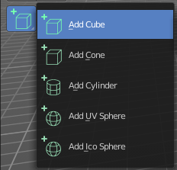
This tools appears in object and edit mode with the correct object types. The tools allows you to create primitives by dragging with the mouse. First you create a ground plane by dragging a rectangle. Then you release the mouse and drag the mouse upwards to create the third dimension of it. And a left click makes the object real then.
You can choose between five primitive types. Cube, Cone, Cylinder, UV Sphere and Icosphere.
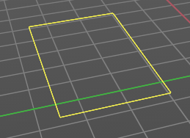
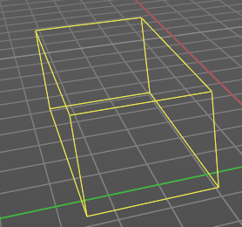
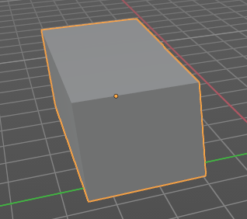

By default the ground plane starts to scale from one of the edges.
Holding down ALT key while dragging scales from the center instead of the default corner.
Holding down Shift key while dragging allows you to scale uniformly.
Holding down CTRL while dragging snaps to other objects.

Add Cube
Adds a cube primitive.

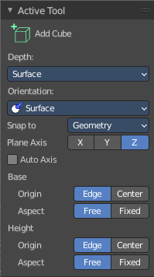
Tool Settings

Depth

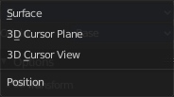
Position
How to position the primitive.

Surface
Start placing on the surface. The 3d cursor acts as a fallback.

3D Cursor Plane
Start placement using a point that is projected at the selected axis at the 3d cursor position

3D Cursor View
Start placement using the mouse cursor projected onto the view plane.

Orientation
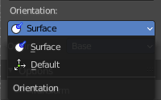
In which orientation the new object to create.

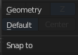
Snap To
The target for snapping. Geometry snaps to existing mesh geometry. Default snaps to the ground.

Plane Axis
What plane axis to use.

Auto Axis
Select the closest axis when placing objects. Surface overrides.

Base

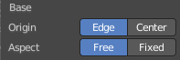
Origin
From where to scale the primitive. From one of its corners or from the center.

Aspect
Scale uniformly or in drag direction.

Height

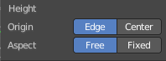
Origin
From where to scale the primitive. From one of its corners or from the center.

Aspect
Scale uniformly or in drag direction.

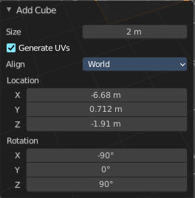
Last Operator Add Cube Panel
Size is in real the size of the Cube.
Generate UV's creates UV's for this primitive.
Align to view aligns the geometry to the chosen view. World, View or 3D cursor.
Location defines the location of the Cube.
Rotation defines the rotation of the Cube.

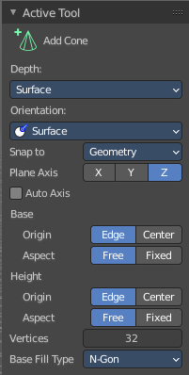
Add Cone
Adds a cone primitive.

Tool Settings

Depth

Position
How to position the primitive.

Surface
Start placing on the surface. The 3d cursor acts as a fallback.

3D Cursor Plane
Start placement using a point that is projected at the selected axis at the 3d cursor position

3D Cursor View
Start placement using the mouse cursor projected onto the view plane.

Orientation
In which orientation the new object to create.

Snap To
The target for snapping. Geometry snaps to existing mesh geometry. Default snaps to the ground.

Plane Axis
What plane axis to use.

Auto Axis
Select the closest axis when placing objects. Surface overrides.

Base

Origin
From where to scale the primitive. From one of its corners or from the center.

Aspect
Scale uniformly or in drag direction.

Height

Origin
From where to scale the primitive. From one of its corners or from the center.

Aspect
Scale uniformly or in drag direction.

Vertices
The number of vertices for the cone ground plane.

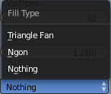
Base Fill Type
Defines how the Base face is filled.
Nothing means you have no base face.
N-Gon means that the base face is an N-Gon face.
Triangle Fan means that the base face is triangulated.

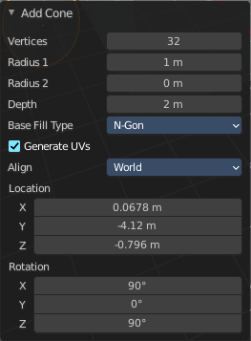
Last Operator Add Cone Panel
Vertices defines of how much vertices the circle is made.
Radius 1 defines the base radius of the Cone.
Radius 2 defines the top radius of the Cone.
Depth defines the length of the Cone.

Base Fill Type defines how the Base face is filled.
- Nothing means you have no base face.
- N-Gon means that the base face is an N-Gon face.
- Triangle Fan means that the base face is triangulated.
Generate UV's creates UV's for this primitive.
Align to view aligns the geometry to the chosen view. World, View or 3D cursor.
Location defines the location of the Cone.
Rotation defines the rotation of the Cone.

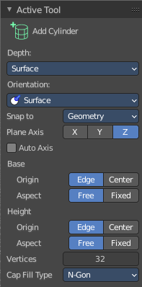
Add Cylinder
Adds a cylinder primitive.

Tool Settings

Depth

Position
How to position the primitive.

Surface
Start placing on the surface. The 3d cursor acts as a fallback.

3D Cursor Plane
Start placement using a point that is projected at the selected axis at the 3d cursor position

3D Cursor View
Start placement using the mouse cursor projected onto the view plane.

Orientation
In which orientation the new object to create.

Snap To
The target for snapping. Geometry snaps to existing mesh geometry. Default snaps to the ground.

Plane Axis
What plane axis to use.

Auto Axis
Select the closest axis when placing objects. Surface overrides.

Base

Origin
From where to scale the primitive. From one of its corners or from the center.

Aspect
Scale uniformly or in drag direction.

Height

Origin
From where to scale the primitive. From one of its corners or from the center.

Aspect
Scale uniformly or in drag direction.

Vertices
The number of vertices.
Cap Fill Type defines how the cap face is filled.
- Nothing means you have no face at the top and the bottom of the Cylinder.
- N-Gon means that the cap face is an N-Gon face.
- Triangle Fan means that the cap face is triangulated.

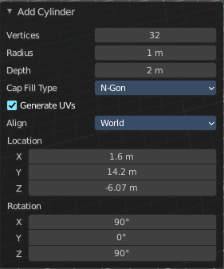
Last Operator Add Circle Panel
Vertices defines of how much vertices the circle is made.
Radius defines the radius of the Cylinder.
Depth defines the length of the Cylinder.

Cap Fill Type defines how the cap face is filled.
- Nothing means you have no face at the top and the bottom of the Cylinder.
- N-Gon means that the cap face is an N-Gon face.
- Triangle Fan means that the cap face is triangulated.
Generate UV's creates UV's for this primitive.
Align to view aligns the geometry to the chosen view. World, View or 3D cursor.
Location defines the location of the Cylinder.
Rotation defines the rotation of the Cylinder.

Add UV Sphere
Adds a UV sphere primitive.

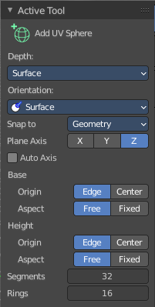
Tool Settings

Depth

Position
How to position the primitive.

Surface
Start placing on the surface. The 3d cursor acts as a fallback.

3D Cursor Plane
Start placement using a point that is projected at the selected axis at the 3d cursor position

3D Cursor View
Start placement using the mouse cursor projected onto the view plane.

Orientation
In which orientation the new object to create.

Snap To
The target for snapping. Geometry snaps to existing mesh geometry. Default snaps to the ground.

Plane Axis
What plane axis to use.

Auto Axis
Select the closest axis when placing objects. Surface overrides.

Base

Origin
From where to scale the primitive. From one of its corners or from the center.

Aspect
Scale uniformly or in drag direction.

Height

Origin
From where to scale the primitive. From one of its corners or from the center.

Aspect
Scale uniformly or in drag direction.

Segments
Defines of how much segments the sphere has vertically.

Rings
Defines how much rings the sphere has horizontally.

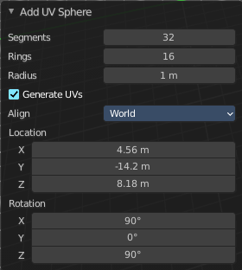
Last Operator Add UV Sphere Panel
Segments defines of how much segments the sphere has vertically.
Rings defines how much rings the sphere has horizontally.
Size defines the radius of the UV Sphere.
Generate UV's creates UV's for this primitive.
Align to view aligns the geometry to the chosen view. World, View or 3D cursor.
Location defines the location of the Sphere.
Rotation defines the rotation of the Sphere.

Add Icosphere
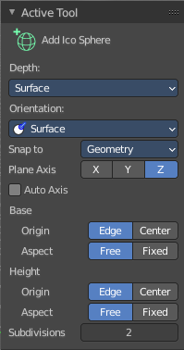
Adds an icosphere primitive.

Tool Settings

Depth

Position
How to position the primitive.

Surface
Start placing on the surface. The 3d cursor acts as a fallback.

3D Cursor Plane
Start placement using a point that is projected at the selected axis at the 3d cursor position

3D Cursor View
Start placement using the mouse cursor projected onto the view plane.

Orientation
In which orientation the new object to create.

Snap To
The target for snapping. Geometry snaps to existing mesh geometry. Default snaps to the ground.

Plane Axis
What plane axis to use.

Auto Axis
Select the closest axis when placing objects. Surface overrides.

Base

Origin
From where to scale the primitive. From one of its corners or from the center.

Aspect
Scale uniformly or in drag direction.

Height

Origin
From where to scale the primitive. From one of its corners or from the center.

Aspect
Scale uniformly or in drag direction.

Subdivisions
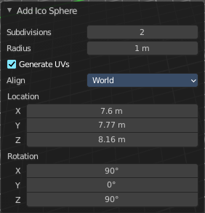
The subdivision level of the Ico Sphere.

Last Operator Add Ico Sphere Panel
Subdivisions defines the subdivision level of the Ico Sphere.
Size defines the radius of the Ico Sphere.
Generate UV's creates UV's for this primitive.
Align to view aligns the geometry to the chosen view. World, View or 3D cursor.
Location defines the location of the Sphere.
Rotation defines the rotation of the Sphere.

